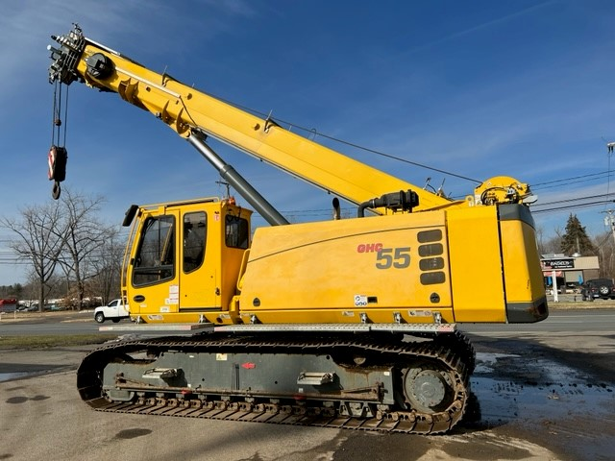

**Selling Price:** $355,000 USD

**FOB:** Manchester, Connecticut, USA

**Availability:** Immediate

Plus Applicable Taxes / Subject to Prior Sale

**One (1) Used 2016 Grove GHC55, S/N: 55.5.214, 55 Ton Capacity Telescopic Boom Crawler Crane, Equipped As Shown Below:**

|  |  |
| --- | --- |
| - 30’ 10” – 99’ 9” 4-Section Sequenced Synchronized  Full Power Main Boom  - 21’ 4” Offsettable Swingaway Extension  - Swingaway Offsetts at 0 and 40 Degrees  - 21’ 4” Fly Jib Extension  - Auxiliary Boom Nose  - Five Sheave Main Boom Nose  - Main & Auxiliary Hoists  - Drum Rotation Indicators  - Operator’s Cab Tilts to 15 Degrees  - Ergonomic Control Panels  - Load Sensing Electric Dual Axis Control Joysticks  - Radio Remote Control System  - Air Conditioning for Operator’s Cab  - Pole Claw Preparation with Tool Circuit  - 360 Degree Continuous Swing | - Pinion Lubrication for Slewing Gear w/ Pump  - Cummins QSB4.5 (Tier IV Final) Diesel Engine  - 19,621 Lbs Total Counterweight  - Hydraulically Extendable Undercarriage  - Maintenance-Free Crawlers (59 Track Shoes)  - 36” Triple-Bar Track Shoes  - 2-Stage Track Motors for High Travel Speed  - “Graphical RCL” Load Moment Indicator  - External RCL Light Bar  - Windspeed Indicator Displayed through RCL  - Anti Two Block & WADS “Work Area Definition” Systems  - One Rotating Beacon Light on Top of Cab  - Two Additional LED Lights Mounted on Base Boom  - Foldable Catwalk on Both Sides of S/S  - 38.5 Ton 3-Sheave Hookblock  - 5.5 Ton Headache Ball  - Approximate Hours: 2,692 Hours (6/8/22) |

**2016 GROVE GHC55, S/N: 55.5.214**

55 Ton Telescopic Boom Crawler Crane